Basel M. Mostafa Sayed
Baselmohamed802@gmail.com
Abstract
[Draw your reader in with an engaging abstract. It is typically a short summary of the document.
When you’re ready to add your content, just click here and start typing.]
Machine Learning Notes
A Document covering all important topics for Machine Learning.

Table of Contents
No table of contents entries found.

Table of Figures:
No table of figures entries found.

Chapter 1: Classification
Classification is a supervised machine learning technique used to predict categories or labels in datasets or applications that require Categorical outputs (Two classes/categories or more).
For example:
- Determining wither, a patient has COVID-19 or not.
- Checking if an email is spam or non-spam.
Types of Classification:
1. Binary Classification:
- Simplest kind of Classification, with only two classes present, it is either one or the other.
2. Multiclass Classification:
- Classification situation with multiple classes present.
3. Multi-label Classification:
- The model can assign multiple labels to a single instance simultaneously.
- Photo Tagging: A single photo can be tagged with "Mountain", "Lake", "Forest", and "Sunset" all at once.
- Movie Genre Classification: A movie can belong to multiple genres like "Action", "Comedy", and "Sci-Fi".
- Document Topics: A news article can be about "Politics", "Economics", and "Technology" simultaneously.
Common Classification Algorithms:
There are two types of classifiers depending on the nature of the dataset and the application.
Linear Classifiers:
- Logistic Regression.
- Linear Support Vector Machines (SVM).
- Single-layer Perceptron.
- Stochastic Gradient Descent (SGD) Classifier.
Non-Linear Classifiers:
- K-Nearest Neighbors (KNN).
- Support Vector Machines (Non-linear Kernel).
- Naïve Bayes.
- Decision Tree classifiers.
- Ensemble Learning Classifiers.
- Random Forest.
- Gradient Boosting Machines (XGBoost, AdaBoost).
- Bagging Classifier.
- Extra Trees Classifier.
- Voting Classifier.
- Multi-layer Artificial Neural Networks (ANNs).

Classification Metrics
Primary goal of metrics is to create a model capable of properly assigning correct labels or categories to new observations based on its old/given information.
1. Confusion Matrix:
It is a table that summarizes the performance of a classification algorithm.
- True Positives (TP): When the model predicted class matched the true class.
- True Negatives (TN): When the model predicted the negative class correctly.
- False Positives (FP): When the model falsely predicts a positive class when it is negative, for example, The model predicted COVID-19 for the patient when true testing came out that the patient does not have COVID-19.
- False Negatives (FN): When the model falsely predicts a negative class when it was positive, for example, The model predicted the patient does not have COVID-19, but true testing came out that the patient had COVID-19.
2. Accuracy:
Measures the proportion of correctly predicted instances for both true positives and true negatives among all other classifications made:
$$\frac{TN+TP}{TP+TN+FP+FN}$$
Advantages:
- Easy to Interpret.
- Suitable only for Balanced Datasets.
Disadvantages:
- Misleading with Imbalanced Datasets.
- Misleading with Critical Applications (Medical Diagnostic, etc.).
3. Precision:
Measures how many Positives out of all Positives (True and False) were actually True positives.
$$\frac{TP}{TP+FP}$$
Use cases:
- Medical Diagnoses, Precision along with Recall are of utmost importance.
- Spam Detection and other sensitive (often imbalanced applications).
4. Recall (Sensitivity):
It is a metric used to assess a model’s ability to correctly identify all positive predictions out of all that which was correctly positive (True Positive) with incorrect negatives (False Negative).
$$\frac{TP}{TP+FN}$$
5. F1-Score:
It is an all-round score that combines both precision and recall into a single value.
$$2*(\frac{Precision*Recall}{Precision+Recall})$$
Advantages:
- Correctly representing class imbalance.
- Balancing Precision and Recall.
- Single Metric for Model Evaluation.
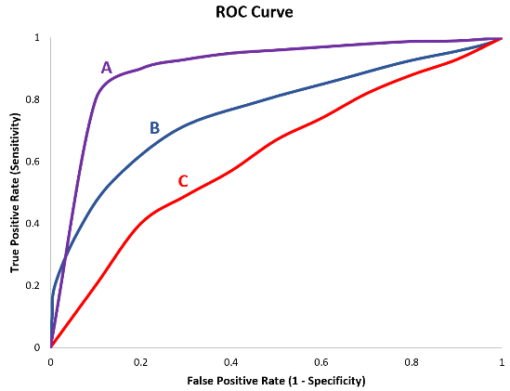
6. ROC Curve:
Figure 1: ROC Curve.
Receiver Operating Characteristic curve graphs the Recall (Sensitivity) to 1 minus the Recall (Specificity).
Generally speaking, the more the curve is bent towards the top left, the better the model is at performing.
Sometimes though not everything is simple, that’s why we use Area Under the Curve (AUC) to figure out which model curve is better exactly.
The AUC provides a single scalar value that summarizes the model's ability to rank positive instances higher than negative instances, regardless of the specific threshold chosen for classification. Higher AUC values indicate better model performance.
- An AUC of 0.5 indicates that the model's performance is equivalent to random guessing.
- An AUC of 1.0 indicates perfect discrimination, where the model can perfectly distinguish between positive and negative instances at all thresholds.

